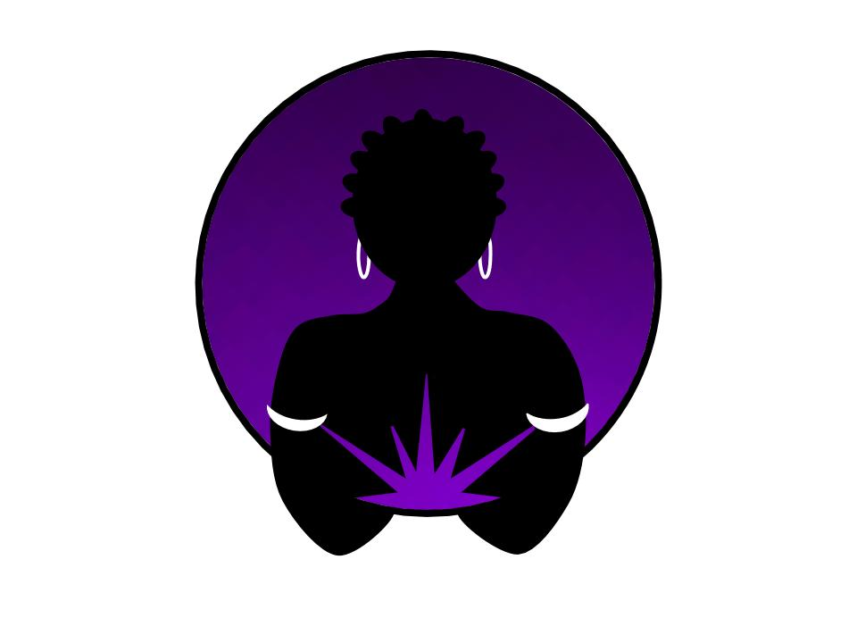

**Sistahs In Silence** is a series of retreats designed for and by women of color. We intentionally design each retreat to teach meditation and movement as tools of self-awareness, self-care, and self-management. We believe meditation and movement practices create the necessary foundation for deep healing and lasting transformation.

Using a combination of individual and group sessions we will share practices that we believe will help to support your immediate and sustainable rejuvenation.

Continued application of the meditation and movement practices we introduce during the **Restoration Retreat** may lead to:

* Decreased feelings of overwhelm
* Feeling more deeply connected to spirit
* Greater sense of purpose and calling
* Increased sense of emotional wellbeing
* Increased clarity and creativity
* More responsive communications habits

While the depth of your experience is ultimately up to you, know that we’ll be there supporting your journey to sacred lightness every step of the way.

## Investment:

$6495.00/person (USD)

Includes: All meals, retreat materials, customized Primordial Sound Meditation mantra, 1-1 follow-up session, ongoing monthly meditation circles, and more!

## Contact:

### EMail

[admin@davedarussell.com](mailto:admin@davedarussell.com)

### Phone

253-709-6706

### Web

<https://davedarussell.com>

# “Me and you, we got more yesterday than anybody. We need some kind of tomorrow.” *– from Beloved, Toni Morrison*

You’re done. You are so completely, wholly, and totally done. You’ve given it everything you’ve got and you’ve got no more to give. It’s time for a **Restoration Retreat**.

**Restoration Retreats** are an invitation to put yourself first and do for you what you so consistently, and generously do for others. This retreat is for you if you’ve burned out, are ready to tap out, or simply want out of the chaos and constant demands of daily life.

We will facilitate a safe space for you to *lay it all down*, restore, and learn how not to give all of yourself away. We’ll also help you to create a habit of caring for self as a foundation for caring for others. Our **Restoration Retreats** are like taking a five-day workshop that teaches you to put on your oxygen mask first!

July 2020

Seattle, WA

# It’s time to

# RESTORE

# and give yourself a break

Retreat location (Coming soon)

Address (Coming soon)

Seattle, WA

Telephone (Coming soon)

Website (Coming soon)

While lodging is included in the retreat price, single occupancy costs an additional $TBD/person.

### **SOUL LIGHT is 100% owned and operated by women of color. Copyright © SOUL LIGHT 2017.**

## Location:

You can expect a dynamic experience each day of the retreat. It is important to us that you know what you can expect. Then we ask you to hold it lightly in that we reserve the responsibility to adjust the schedule as opportunities present themselves.

**Sample schedule:**

* 6 AM Sunrise meditation
* 7 AM Morning movement
* 9 AM Breakfast
* 10 AM Morning session
* 12 PM Lunch
* 2 PM Afternoon session (I)

& Private sessions

* 4 PM Afternoon session (II)

& Private sessions

* 6 PM Dinner
* 8 PM Group meditation

& Sistah Circles

We promise to facilitate a personal and collective experience that invites healing and transformation for all sistahs in our care.

So come. Come and rest in the company of your sistahs. Come and lay it down.