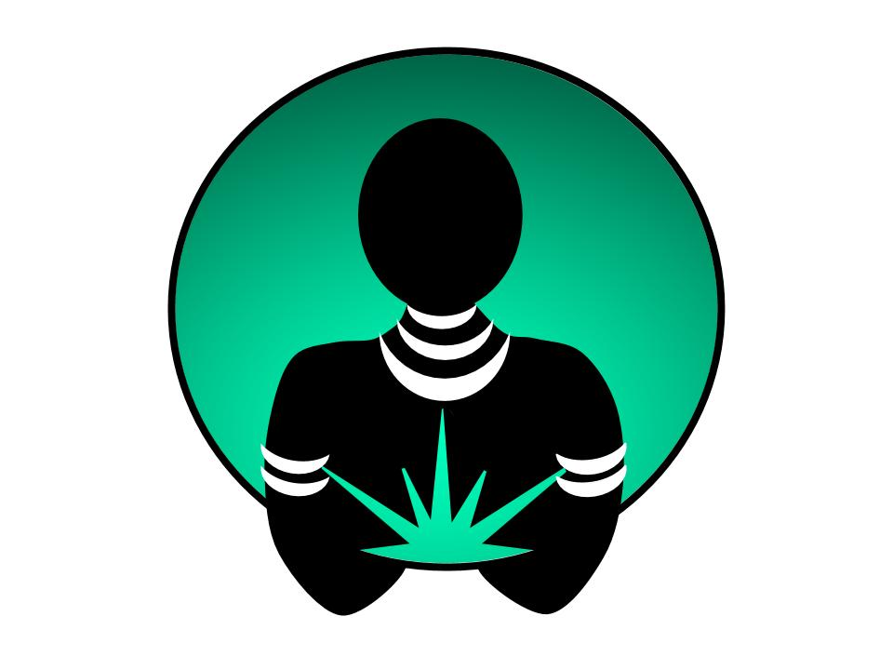

Despite our best intentions, we may find ourselves holding on to relationships, stories, and beliefs that no longer serve us. If you’ve been holding on to something and begun the process of letting it go, now may be a great time to join us for a **Release Ritual**.

**Release Rituals** use ceremony to support you as you recall, reflect, and honor life experiences that have run their course and taught you whatever they came to teach. This retreat is for you if you are ready to *lay it down* for good and accept that you did the best you could with what you had at that point in time.

We will facilitate a safe space for you to *lay it all down* and mourn what was as you embrace what is to come. **Release Rituals** are truly acts of self-love and the ultimate lightening of your load.

**Sistahs In Silence** is a series of retreats designed for and by women of color. We intentionally design each retreat to teach meditation and movement as tools of self-awareness, self-care, and self-management. We believe meditation and movement practices create the necessary foundation for deep healing and lasting transformation.

Using a combination of individual and group sessions we will share practices that we believe will help to support your immediate and sustainable rejuvenation.

The continued application of the meditation and movement practices we introduce during the **Release Ritual** may lead to:

* Decreased attachment to the past
* Expanded sense of emotional wellbeing
* Feeling more deeply connected to spirit
* Greater sense of self-acceptance
* Increased connection to the present
* Lasting forgiveness of self and others

While the depth of your experience is ultimately up to you, know that we’ll be there supporting your journey to sacred lightness every step of the way.

## Investment:

$3750.00/person (USD)

Includes: All meals, retreat materials, customized Primordial Sound Meditation mantra, 1-1 follow-up session, ongoing monthly meditation circles, and more!

Retreat location (Coming soon)

Address

Seattle, WA Zip code

Telephone

Website

While lodging is included in the retreat price, single occupancy costs an additional $TBD/person.

# “Breathe. Let go. And remind yourself that this very moment is the only one you know you have for sure. *– Oprah Winfrey*

August 2020

Seattle, WA

# Now is the time to

# RELEASE IT

# and forgive yourself

### **SOUL LIGHT is 100% owned and operated by women of color. Copyright © SOUL LIGHT 2017.**

### EMail

[admin@davedarussell.com](mailto:admin@davedarussell.com)

### Phone

253-709-6706

### Web

<https://davedarussell.com>

## Contact:

## Location:

You can expect a dynamic experience each day of the retreat. It is important to us that you know what you can expect. Then we ask you to hold it lightly in that we reserve the responsibility to adjust the schedule as opportunities present themselves.

**Sample schedule:**

* 6 AM Sunrise meditation
* 7 AM Morning movement
* 9 AM Breakfast
* 10 AM Morning session
* 12 PM Lunch
* 2 PM Afternoon session (I)

& Private sessions

* 4 PM Afternoon session (II)

& Private sessions

* 6 PM Dinner
* 8 PM Group meditation

& Sistah Circles

We promise to facilitate a personal and collective experience that invites healing and transformation for all sistahs in our care.

So come. Come and rest in the company of your sistahs. Come and lay it down.