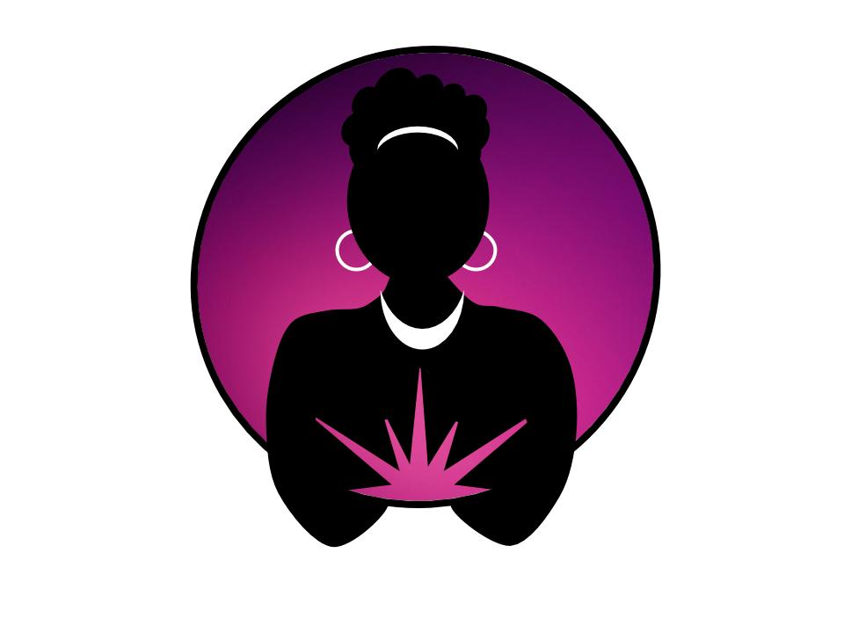

You’ve got to be kidding me! Often, that’s how we feel about the absurdities of life as a woman of color in this world. If you find yourself shaking your head or wondering, “Is this crap for real?” it’s time to join us for a **Reconnection Retreat**.

**Reconnection Retreats** invite you to explore how ancestral threads and sacred bonds can help you to remember you are not alone. This retreat is for you if you’ve been feeling isolated, exhausted by disbelief, or want to re-orient yourself to what really matters to you.

We will facilitate a safe space for you to *lay it all down* and reconnect to the center of your joy. We’ll also help you to create a habit of centering in your most sacred self and seeking the support of sistahs like you.

# “Learn to be quiet enough to hear the genuine within yourself so that you can hear it in others.” *– Marian Wright Edelman*

You can expect a dynamic experience each day of the retreat. It is important to us that you know what you can expect. Then we ask you to hold it lightly in that we reserve the responsibility to adjust the schedule as opportunities present themselves.

**Sample schedule:**

* 6 AM Sunrise meditation
* 7 AM Morning movement
* 9 AM Breakfast
* 10 AM Morning session
* 12 PM Lunch
* 2 PM Afternoon session (I)

& Private sessions

* 4 PM Afternoon session (II)

& Private sessions

* 6 PM Dinner
* 8 PM Group meditation

& Sistah Circles

We promise to facilitate a personal and collective experience that invites healing and transformation for all sistahs in our care.

So come. Come and rest in the company of your sistahs. Come and lay it down.

**Sistahs In Silence** is a series of retreats designed for and by women of color. We intentionally design each retreat to teach meditation and movement as tools of self-awareness, self-care, and self-management. We believe meditation and movement practices create the necessary foundation for deep healing and lasting transformation.

Using a combination of individual and group sessions we will share practices that we believe will help to support your immediate and sustainable rejuvenation.

The continued application of the meditation and movement practices we introduce during the **Reconnection Retreat** may lead to:

* Feeling more deeply connected to spirit
* Decreased feelings of isolation
* Greater sense of sisterhood with other women of color
* Improved communication in close and new relationships
* Increased willingness to ask for help

While the depth of your experience is ultimately up to you, know that we’ll be there supporting your journey to sacred lightness every step of the way.

## Investment:

$1375.00/person (USD)

OR

$1875.00/pair (USD)

Includes: Select meals, retreat materials, and introduction to Primordial Sound Meditation, ongoing monthly meditation circles, and more!

## Contact:

### Email

[admin@davedarussell.com](mailto:admin@davedarussell.com)

### Phone

253-709-6706

### Web

<https://davedarussell.com>

Andaz Scottsdale Resort & Spa

6114 N Scottsdale Road

Scottsdale, AZ 85253

(480) 368-1234

<https://scottsdale.andaz.hyatt.com>

Reduced rates begin at $239 available with code: *Sistahs In Silence*

### **SOUL LIGHT is 100% owned and operated by women of color. Copyright © SOUL LIGHT 2017.**

## Location:

May 2020

Scottsdale, AZ

# Make time to RECONNECT

# to your sistahs & yourself